Name: ___________________________ Date: ____________________________
UNIT 3 LESSON 5

AIM: | SWBAT plot positive rational numbers on a number line

THINK ABOUT IT!
For each part of the problem below, use the number line provided, show all of your work and represent your thinking accurately. Be prepared to explain how you plotted the point on the number line.

- Plot 1/3 on the number line

0
1

- Plot and label any fraction between 0 and 1 on the number line

0
1

- Plot 0.7 on the number line

0
1

- Plot and label any decimal between 0 and 1 on the number line

0
1

Key Point
Any fraction and decimal can be represented on a ____________________________________.

Interaction with New Material

Ex. 1) Every hour for four hours, Alicia measured the temperature outside and recorded the temperatures in the table below.

Hour | 1 | 2 | 3 | 4
Temperature (in °F) | 1.2 |  | 1 ½ | 0.42

Create a number line and plot each temperature.

PARTNER PRACTICE
- CFS for top quality work
  - Number line is drawn neatly and accurately (including a reasonable scale)
  - Number line is spaced appropriately
  - Point is plotted directly on the number line and labeled

Bachelor Level

- For each rational number below, create a number line and plot a point to represent the number.

- ¾

- 0.8

- 1.25

Master Level

- On the number line below, plot the following numbers:

3 ½, 0.5, 0.8, 1 ¾, 2.25

- Create a number line and place the four temperatures from last February on the number line.
Date | Temperature (in degrees Fahrenheit)
February 3rd | 0.25
February 4th | 3
February 5th
February 6th | 2 ¼

INDEPENDENT PRACTICE
- CFS for top quality work
  - Number line is drawn neatly and accurately (including a reasonable scale)
  - Number line is spaced appropriately
  - Point is plotted directly on the number line and labeled

Bachelor Level
- For each rational number below, create a number line and plot a point to represent the number.

- ¼

- 1.3

- 0.05

2) What rational number is represented by point A on the number line?
A

2
3

Master Level
3) What rational number is represented by point D on the number line? Write at least two possible options.

D
3
5
4

_________________ ___________________

4) Plot |-3 ¾ | on a number line

5) The temperature in Juneau, Alaska was 7 ¼ degrees on Tuesday, 8.5 degrees on Wednesday, and 8.65 degrees on Thursday.

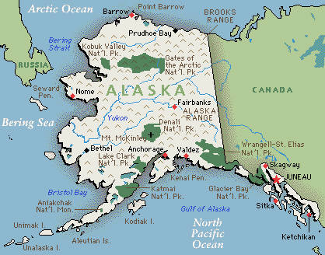
Part A: Plot the points from above on a number line

Part B: On Friday, the temperature was warmer than Wednesday and colder than Thursday. Plot and label another point on the number line to represent what Friday’s temperature could have been.

6) Using fractions and decimals, determine two or more ways to represent the point on the number line below numerically.

0
2

7) Create a number line and plot the following values on the number line. Label them using the designated letter.

A. 0.1 F: |-0.5| G: 0.95 H: |0.25|

8) Marco said that the point on the number line is . Do you agree or disagree with him? Explain.

0
1

____________________________________________________________________________________

____________________________________________________________________________________

____________________________________________________________________________________

9) Which number line shows the location of ½ , |-1¼ |, ?

0

1
2

0

1
2

0

1
2

0

1
2

10) What numbers are represented by points A and C on the number line below?
B
A
0
1

A - _____________

B - _____________

11) Which numbers represent the point on the number line below? Circle all that apply.

0
1

  - 0.7
  - 0.8
  - ||

PhD Level

12)
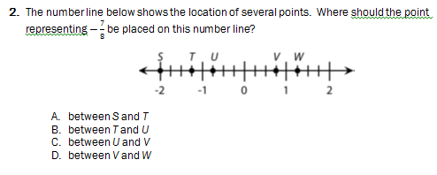
Identify the rational number that corresponds to each of the lettered points above and order them from greatest to least.

13)
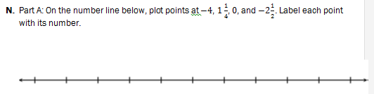

Name: ______________________________ Date: _______________________
EXIT TICKET
Self-assessment | I mastered the learning objective today. | I am almost there. | Need more practice and feedback.
Teacher feedback | You mastered the learning objective today. | You are almost there. | You need more practice and feedback.

- Which rational number is represented by point A on the number line below?
Circle all that apply. Explain how you know.
0
2
1
A
A
- 1
- 1.1
- 1.2

____________________________________________________________________________________

____________________________________________________________________________________

____________________________________________________________________________________

____________________________________________________________________________________

____________________________________________________________________________________

2) Create a number line and plot 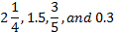. Label each point.

