Name: ___________________________ Date: ____________________________

UNIT 8 LESSON 9

|  |  |
| --- | --- |
| AIM: | SWBAT solve area problems involving compound figures on coordinate grids |

**THINK ABOUT IT!**

Determine the area of the figure drawn on the coordinate grid below. Explain the strategy that you used to determine the area of the figure.

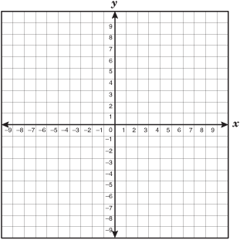

Key Point

|  |
| --- |
| ____________________ of compound figures can be found using decomposition. |

**Interaction with New Material**

*Ex. 1)* Plot the points on the coordinate grid below to form pentagon PQRST.

P (1, -4), Q (5, -2), R (9, -4), S (7, -8), and T (3, -8)



What is the figure’s area?

**PARTNER PRACTICE**

CFS:

* + Annotations: Circle key words, underline what you’re solving for
  + Figure is plotted accurately (as needed)
  + Figure is decomposed
  + Dimensions (base/height) are labeled
  + Formulas are written
  + All calculations are shown
  + Answer statement is BOXED

|  |
| --- |
| *Bachelor Level* |

1. Determine the area of the figure drawn on the grid below



Area: ______________________________

What is the perimeter of the figure?

Perimeter: __________________________

|  |
| --- |
| *Master Level* |

1. Measure the area of the figure on the coordinate plane below.



**INDEPENDENT PRACTICE**

|  |
| --- |
| *Bachelor Level* |

1. Graph the points below on the coordinate plane. Connect the points with line segments in the order that you graphed them. Then, find the area of the figure you created.

**A(-9, 1) B(-9, 9) C(-6, 9) D(-6, 5) E(-2, 5) F(-2, 1)**



CFS:

* + Annotations: Circle key words, underline what you’re solving for
  + Figure is plotted accurately (as needed)
  + Figure is decomposed
  + Dimensions (base/height) are labeled
  + Formulas are written
  + All calculations are shown
  + Answer statement is BOXED

|  |
| --- |
| *Master Level* |

1. Measure the area of the figure on the coordinate plane below.



1. Measure the area of the figure on the coordinate plane below.



|  |
| --- |
| *PhD Level* |

1. Shon is redesigning the basement of his house. He drew a sketch of the floor plan for the basement below (each square represents one square foot).



He is working on deciding which type of flooring he will install in the basement. Based on the options below, how much will he save by going with the cheapest option over the most expensive option?

* + - Hardwood Floor: $14.99 per square foot and $299.99 installation fee
    - Tile Floor: $10.99 per square foot and $350.99 installation fee
    - Cement Floor: $19.99 per square foot and $199.99 installation fee

**Name: ______________________________ Date: _______________________**

**U8L9 EXIT TICKET**

|  |  |  |  |
| --- | --- | --- | --- |
| Self-assessment | I mastered the learning objective today. | I am almost there. | Need more practice and feedback. |
| Teacher feedback | You mastered the learning objective today. | You are almost there. | You need more practice and feedback. |

1. Determine the area of the figure below. Show your work.

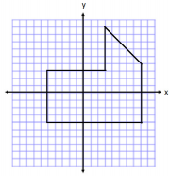

CFS:

* + Annotations: Circle key words, underline what you’re solving for
  + Figure is plotted accurately (as needed)
  + Figure is decomposed
  + Dimensions (base/height) are labeled
  + Formulas are written
  + All calculations are shown
  + Answer statement is BOXED